Assessment Parameters

- Solution Completeness (including all requirements addressed) – 30%
- The appropriate usage of required templates – 10%
- Preparing Use Cases, identifying & categorizing the requirements, writing appropriate test cases for each requirement –60 %

Instructions:
Case Study :

MakeMyJourney is India’s most well known and most preferred online airway, railway & bus booking service providing website. This website is used by the customers & travel agents to avail ticket reservation facilities. You as a Test Engineer need to test this website for its different functionalities & validations.

Reservation and cancellation of tickets can be done using the official website of MakeMyJourney which is www.makemyjourney.co.in.
In this process, you will access the website and will open an account by registering yourself on the site. You will then use this account to book airway, railway or bus ticket and also cancel the reservation that you have made.
You will need to create an email ID account for yourself before you can register and start accessing MakeMyJourney account if you do not have one already.

Q1. Consider the following " MakeMyJourney " scenario & complete the following given
task.
- Indentify and categorize the requirements involved in the given case study using Requirement Itemization Template.

Marks Distribution: [20 Marks]

Criterion | Marks
- Identifying all types of requirements from the given case study i.e. requirements related to security, explicit, implicit, application invocation, application termination, file handling, error handling & system rquirements.  - Identifying queries relevant to the application & requirements given in the case study. | 5
- Writing good, clear and effective requirements keeping in mind the characteristics of good requirements discussed in the class.  - Defining suitable level of priority for the requirements  - Usage of query sheet to maintain queries to be asked to the client & SME.  - Right usage of requirement itemization template. | 15

Q2. Write Use Case for “Sign Up” business functionality from the given case study.
Refer to the Figure 1.1 & Business Rules for the same.

Marks Distribution: [20 Marks]

Criterion | Marks
The use cases should adhere to the following:  - Appropriate usage of the use case template  - Indentification of correct actors involved in the use case  - Proper naming convention should be followed for use case names  - Identifying all applicable Preconditions as per the scenario  - Determining the correct Basic Flow and Alternate Flows  - Mentioning precise Post Condtion  - Identifying all applicable success and failure scenarios  - Identifying use case assumptions (If required) | 20

Business Flow 1: Sign Up
- Visit http://www.makemyjourney.co.in link through internet
- From the Home page select Sign Up link.
- Once you click on the Sign Up link you will get navigated to register page & following page will get displayed. Refer to Figure 1.1.
- User needs to fill in the Sign Up Form
- Following are some of the validations that needs to be taken care of while registering on the website
  - All fields marked with (*) are mandatory
  - The username should be between 3 to 10 characters.
  - After entering the username, user need to click on “Check Availability” link to check the availability of the username. It often happens that there may be other people using the same username so it is important to check the availability of user name. Every username must be unique. If the username that you have typed already exists, it will give you a message saying . You will then have to enter a different username.
  - The user can select any of the following values as their Security Question
    - What is your pet’s name?
    - What was the name of your first school?
    - Who was your childhood hero?
    - What is your father’s middle name?
  - First Name & Last Name fields should accept only characters.
  - User should select Gender. The valid values for Gender field is Male & Female
  - User should enter correct and active email id and mobile no. as his login details, account activation & verification codes will be sent to his mail id and an SMS will be sent to his mobile no.
- User need to click on the “Submit” button to complete the registration process.
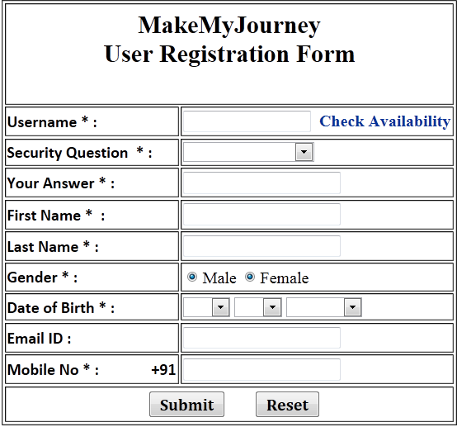
Figure 1.1
- On submitting the form, if all validations are successful, a message window will appear to re-confirm your email id and mobile no. Check your email id and mobile no. and click on “Ok”.
- On clicking on “Ok” button, your registration form will be submitted completely and a window will appear with the “Thank you” message confirming your registration.
Business Flow 2: Activate Account
- User need to get the following details received in his email id:
  - Mobile Verification No.
  - Username
  - Autogenerated Password
- User need to visit the “MakeMyJourney” website again & click on the “Activate Account” on the home page. The following page will be displayed.
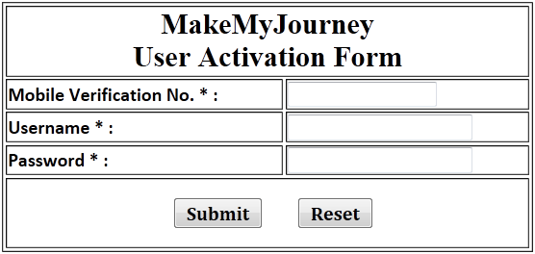
Figure 1.2
- User need to enter the valid Mobile Verification Code. The mobile verification code will have 4 digits.
- User need to enter the valid username (used while registering) & password (sent to the registered email id).
- User need to click on “Submit” button to start ticket reservation process.

Q3. Write test cases for the “Sign Up” web page to validate the user entries with the
help of given requirements.
Refer to the Figure 1.1 & Business Rules for the same.

Marks Distribution: [20 Marks]
Criterion | Marks
The test cases should adhere to the following:  - Identifying positive, negative and relevant test cases from the given case study  - Participant need to write at least TWENTY test cases  - Assumptions (if applicable) for the test cases should be written properly  - The test case id should be written in correct format  - The applicable preconditions for the specific test case should be mentioned in clear and thoughtful manner  - The test condition should be precise and written in proper format  - The test steps & the corresponding test data for the test steps should be written correctly  - The expected result should be written appropriately as per the test steps written for the test case | 20

Following are the software and hardware related requirements that needs to be taken care by the user while accessing web site.

Q.4 Log the defects in Defect Tracking Sheet

Marks Distribution: [10 Marks]
Criterion | Marks
- The participant need to make the entry in Defect Tracking Sheet for all the defects identified  - Every negative test case written can be used as a base for writing defects in the Defect Tracking Sheet  - Participant need to write at least FIVE defects in the Defect Tracking Sheet | 5
The defects logged in the defect tracking sheet should adhere to the  following:  - Every defect should have a unique Defect ID associated with it  - The Defect ID should follow the valid format as per the guidelines  - The appropriate value for the Module Name field should be written  - The Defect Summary & Defect Description should be written with lot of caution and as per the guidelines, tips and tricks of writing defect free defect report discussed during the class  - The Defect Severity and Defect Priority should be defined appropriately  - The status of the defect should be given appropriately  - All other columns/fields of Defect Tracking Sheet should be filled appropriately based on the guidelines discussed during the class | 5

- Software Requirements:
Operating System : 32 bit Operating System - Windows Vista, Windows 7, Windows 10
Browser : Latest versions of leading browsers like Internet Explorer, Google Chrome,
Mozilla Firefox, Opera, Safari

- Hardware Requirements
  - 800 MHz or higher
  - 256 MB RAM or higher
  - System should be enabled for audio and video
- Network Requirement
  - The project needs Internet to fully demonstrate its capabilities.
  - A minimum of 3 MBPs continuous connection is required for showing any improvement brought forth by the product.

